Landowner Report
Station Information
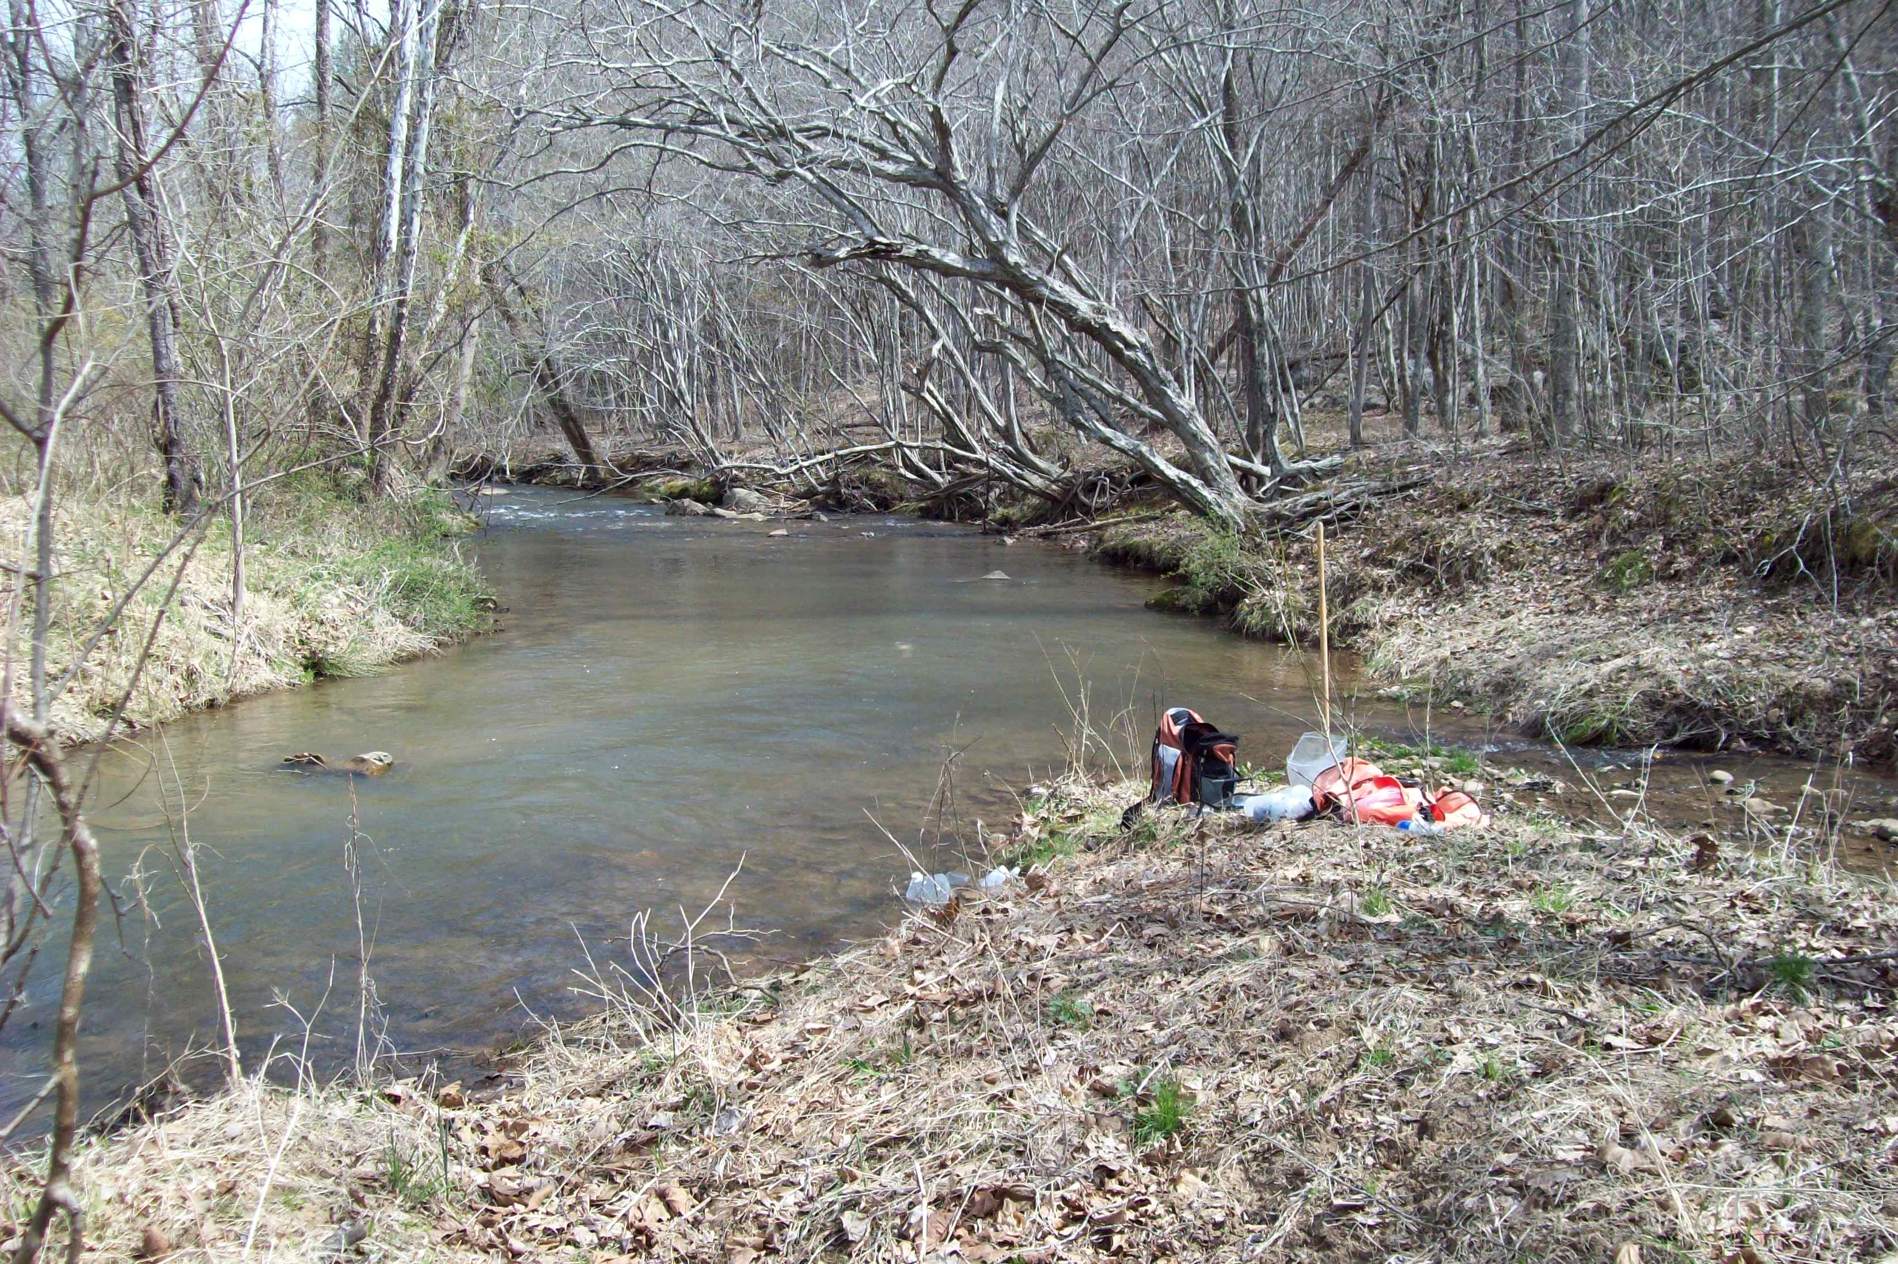
Station ID 2-RED003.65
Stream Name Reed Creek
Description Downstream of Rt. 637
Year 2004, 2011, 2013, 2015
Regional Office BRRO
County Bedford
Basin James
Photo of sampling station, Spring 2015
Data Results
Spring Fall Spring Fall Spring Fall Spring Fall Status
2004 2004 2011 2011 2013 2013 2015 2015
Temperature (C/F) 10.3 18.1 18.0/64 13.2/55 16.1/61 15.6/60 9.4/49 16.8/62 Optimal
Dissolved Oxygen (mg/l) 12.3 9.7 10.0 10.4 10.1 9.6 11.4 9.6 Optimal
pH 6.4 6.2 7.5 6.1 7.4 7.6 6.9 7.5 Optimal
Conductivity (uS) 34 45 30 61 35 54 34 54 Optimal
Bacteria (cfu/100ml) 140 na 160 na 380 na 98 na Optimal
Total Nitrogen (mg/l) 0.54 na 0.56 0.51 0.56 0.34 0.46 0.51 Optimal
Spring Fall Spring Fall Spring Fall Spring Fall Status
2004 2004 2011 2011 2013 2013 2015 2015
Total Phosphorus (mg/l) 0.03 0.04 0.03 0.02 0.05 0.02 0.03 0.04 Optimal
Metals Index (ccu) 0.26 na 0.23 na 0.21 na 0.20 na Optimal
Biological Index (0-100) 67.7 53.7 61.6 71.0 70.6 64.3 71.1 68.5 Optimal
Habitat Index (0-200) 175 158 171 152 175 156 164 152 Optimal
Biologist Comments:
This site was sampled as a part of the Probabilistic Monitoring Program in 2004, 2011, 2013 and 2015. The station was in a remote section of Bedford County several miles upstream of the confluence with the James River. Biomonitoring surveys of aquatic macroinvertebrates resulted in good numbers of pollution-sensitive taxa such as mayflies, stoneflies, and caddisflies. Scores for habitat surveys were in the optimal range with a slight impact from sediment deposition. Fish community sampling resulted in a mix of suckers (torrent, white, and northern hog suckers, golden redhorse), minnows (bluehead chubs, central stonerollers, common shiners, crescent shiners, blacknose dace, fallfish, longnose dace, and rosyside dace), darters (fantail, johnny and stripeback ), blueridge sculpins, margined madtoms and a few game species such as smallmouth bass, rock bass, redbreast sunfish.
Biologist Contact Information:
Larval stonefly “indicator of good water quality”
George Devlin, Regional Biologist
VDEQ- Blue Ridge Regional Office
3019 Peters Creek Road
Roanoke, VA 24109
Phone: 540-562-6826
Email: george.devlin@deq.virginia.gov

The 'Landowner Report’ is not an official site specific VDEQ water quality assessment. This report summarizes water quality findings based on a limited sampling event. The primary application of probabilistic monitoring data is to establish regional/statewide water quality conditions and not to perform a site specific characterization. Please see the enclosed insert for more information.

